To access the **Clinical Clerkship – Approaching the Patient on-line**, you need to connect to the Unibo Moodle educational platform for e-learning services through the following link:

https://virtuale.unibo.it/course/view.php?id=24774

and log in by entering your institutional credentials (@ studio.unibo.it).

Once you have entered the **Clinical Clerkship - Approaching the Patien on-line**, you will find the following sections:

* Heart: physical examination;
* Heart: EKG;
* Lung: physical examination and basic diagnostic tests;
* Heart and lung: examples of diseases;
* Abdomen: physical examination and basic principles of ultrasound;
* Abdomen: examples of diseases;
* Surgical skills;
* Nursing skills.

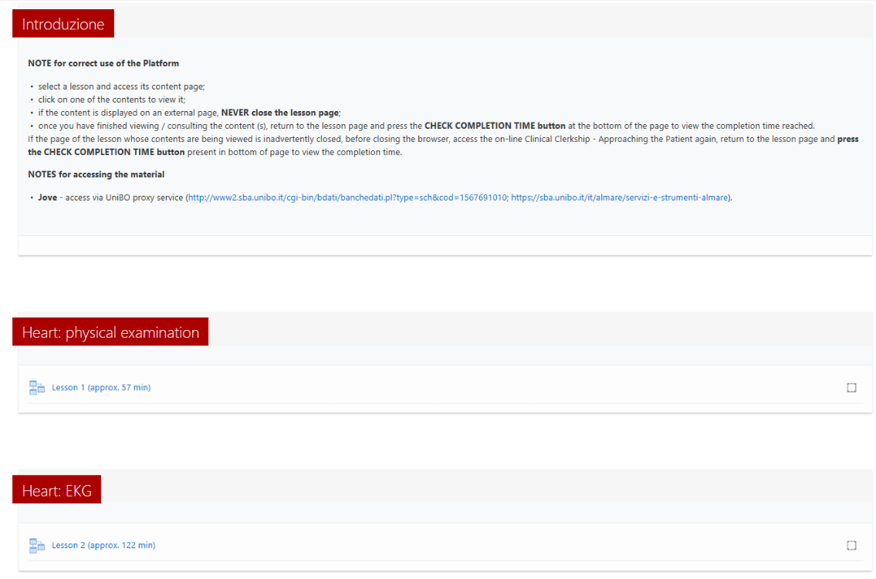

Within these sections you will find educational material in the form of links to external sites that can be reached by **following the notes**.

It is necessary for all the lessons of the section to **consult the material for the minimum time indicated**, a constraint to obtain the completion of each section.



The completion of a lesson will be highlighted by the appearance of a check next to the lesson.



Upon completion of all the lessons provided for the INTERNSHIP, the platform will automatically issue a badge.

The notification of achievement of the Badge will take place both by sending an email to the institutional address and by means of a notice in the notification area within the VIRTUALE platform.

